Worksheet 1
Q.1 Choose the correct option:
- Which of the following are available on clicking the FILE tab?
a) new b) Open c) Save d) All of these
- What is artificial intelligence?
a) A type of computer game
b) A machine’s ability to think and learn like humans
c) A software used only for typing
d) A computer virus
- To rename a file ( or folder),_______________
a) F1 b) F2 c) F5 d) F12
- The Minimize button is present on the ________ bar.
a) Menu b) Title c) Status d) Task
- Which of the following is NOT an example of a smart machines.
a) Robot b) Smart Home devices c) Virtual Assistants d) Typewriter
6. Press __________to permanently delete the selected files.
a) Delete b) Shift + Delete c) Ctrl + D d) Alt + Delete
Q.2 Unscramble the word:
- UTMTAEDO
- CREYLEC IBN
- PLEOXERER
- HITNKIGN
- SEPERNATONIT
- CCAESS
Q.3 Identify the following images:
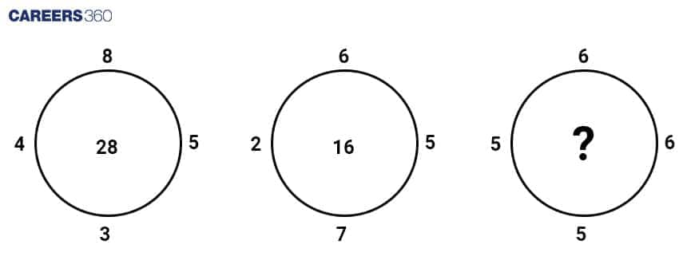
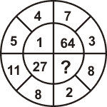
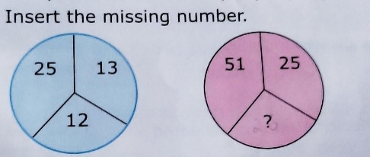

Q.4 Filling the missing steps:
B. You are making a vegetable pulao for your family. Fill in the blanks to complete
the steps.
1. Select a recipe from a recipe book.
2. Check if the ___________are available at home.
3. __________ any missing ingredients.
4. Wash and soak the rice.
5. Wash the vegetables.
6. Peel and chop the ____________
7. Light the stove and put a pan on it.
8. Fry the spices and onions in _______.
9. Add rice.
10. Add the chopped _____________.
11. Add salt.
12. Cover the pan with a lid and cook until done.
Q.5) Identify the names of the tabs indicated by the arrow
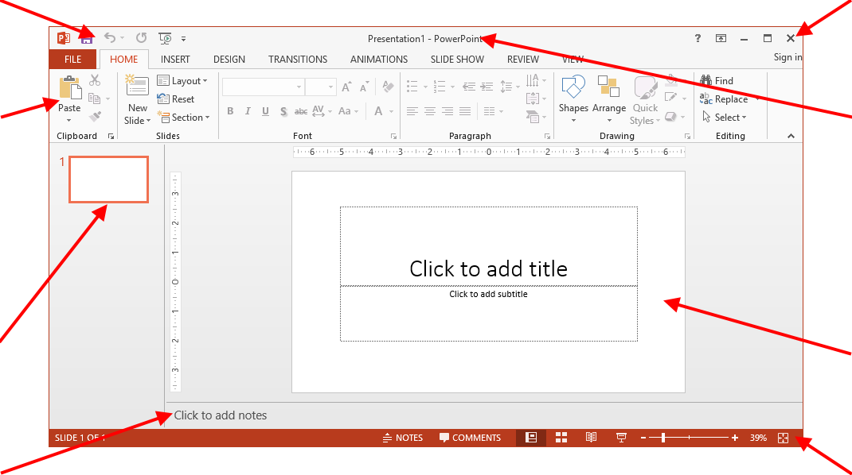

Q.1 Choose the correct option:
- Which of the following are available on clicking the FILE tab?
  - Answer: d) All of these
- What is artificial intelligence?
  - Answer: b) A machine’s ability to think and learn like humans
- To rename a file (or folder), _______________
  - Answer: b) F2 (Standard Windows shortcut)
- The Minimize button is present on the ________ bar.
  - Answer: b) Title (Standard Windows interface)
- Which of the following is NOT an example of a smart machines.
  - Answer: d) Typewriter
- Press __________ to permanently delete the selected files.
  - Answer: b) Shift + Delete (Standard Windows shortcut)

Q.2 Unscramble the word:
- UTMTAEDO — AUTOMATED
- CREYLEC IBN — RECYCLE BIN
- PLEOXERER — EXPLORER (File Explorer)
- HITNKIGN — THINKING
- SEPERNATONIT — PRESENTATION
- CCAESS — ACCESS

Q.4 Filling the missing steps (Step-wise Thinking):
Based on the logical sequencing of tasks:
- Select a recipe from a recipe book.
- Check if the ingredients are available at home.
- Buy / Collect any missing ingredients.
- Wash and soak the rice.
- Wash the vegetables.
- Peel and chop the vegetables.
- Light the stove and put a pan on it.
- Fry the spices and onions in oil / ghee.
- Add rice.
- Add the chopped vegetables.
- Add salt.
- Cover the pan with a lid and cook until done.

Q.5 Identify the names of the tabs indicated by the arrow:
Based on the PowerPoint 2013 interface described in your notes:
- The tab used for Inserting Pictures is the INSERT tab.
- The tab used for the New Slide option is the HOME tab.
- The tab containing New, Open, and Save is the FILE tab.

